**Stack Implementation**

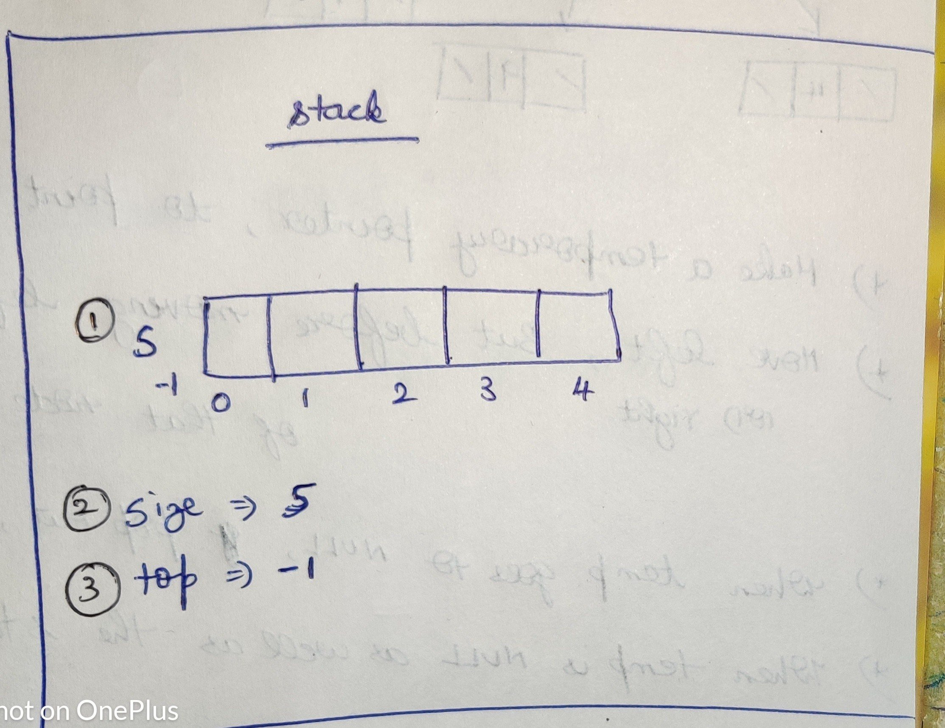

**Stack Overflow** :

Size of the stack =2

3 numbers in Stack.

Hence No possible to enter the third element. So it is Stack Overflow

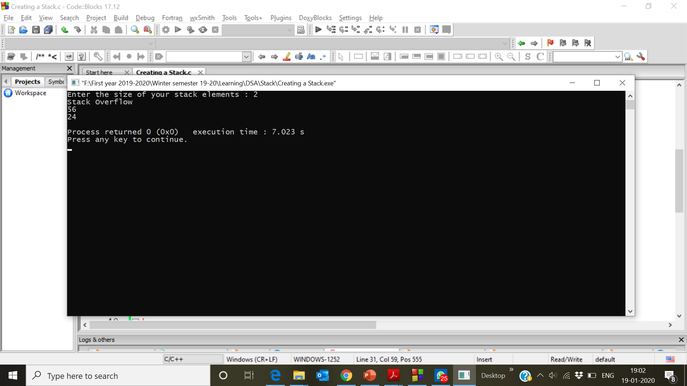

**Push method**

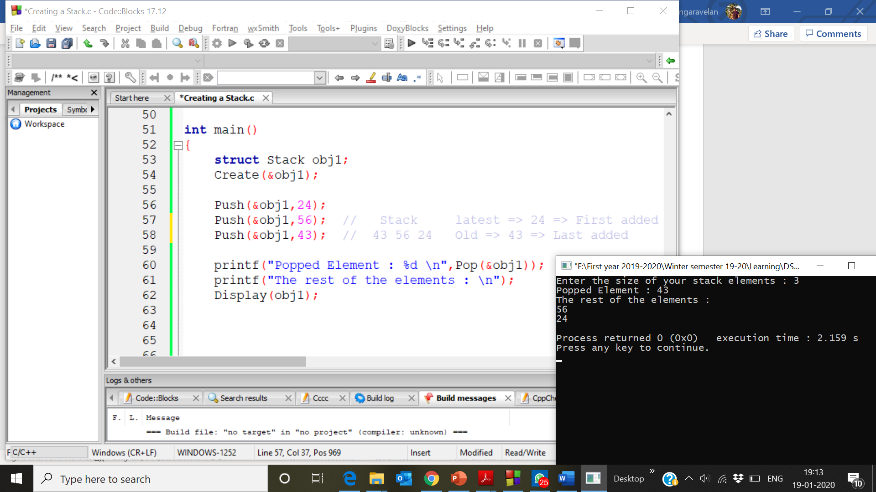

**Pop method**

1) Two elements are there in Stack

2) But we are Popping three elements, So only stack overflow while trying to remove the third element . Since the stack contains only 2 elements.

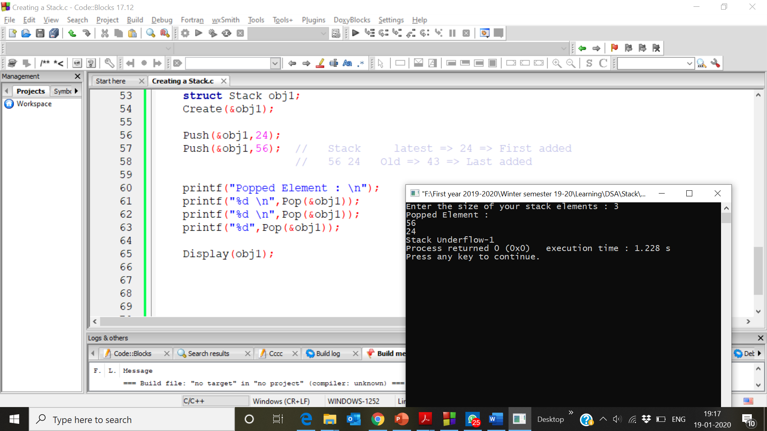

**Peek method**

